import pandas as pd import numpy as np

from sklearn.datasets import load_iris import matplotlib.pyplot as plt

iris = load_iris()

data = iris.data # Features

target_names = iris.target_names # Target names

df = pd.DataFrame(data= np.c_[iris['data'], iris['target']], columns= iris['feature_names'] + ['target'])

# Line graph

plt.figure(figsize=(8,6))

for target in set(iris.target):

subset = df[df['target'] == target]

plt.plot(subset['sepal length (cm)'], subset['petal length (cm)'], marker='o', linestyle='', label=target_names[int(target)]) plt.xlabel('Sepal Length')

plt.ylabel('Petal Length')

plt.title('Iris Sepal Length vs. Petal Length') plt.legend()

plt.show()

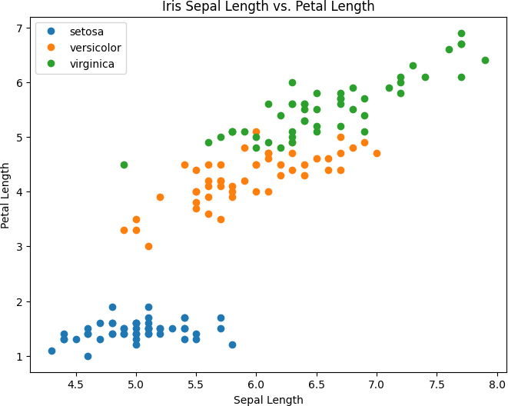

mean_data.plot(kind='area', figsize=(10,6))

plt.title('Average Feature Measurement By Species') plt.ylabel('Average Measurement (cm)')

plt.xticks([0,1,2], target_names) plt.show()

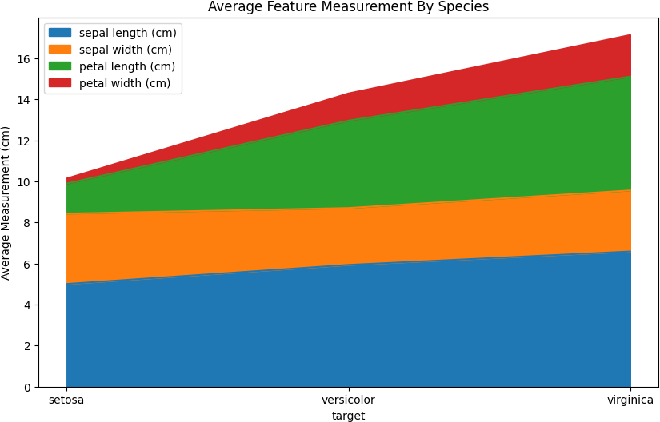

# Bar chart

mean_data = df.groupby('target').mean()

mean_data.plot(kind='bar', figsize=(10,6))

plt.title('Average Feature Measurement By Species') plt.ylabel('Average Measurement (cm)')

plt.xticks([0,1,2], target_names) plt.show()

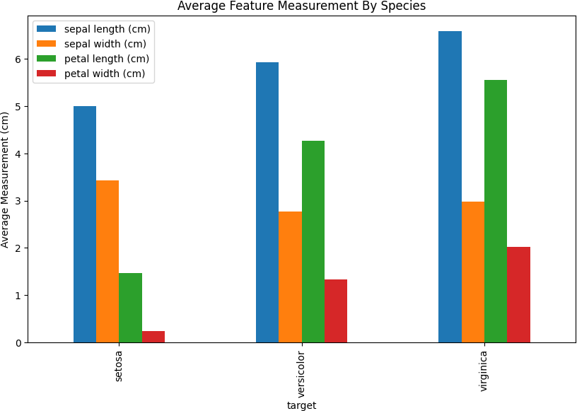

# Pie chart

target_counts = df['target'].value_counts() plt.figure(figsize=(6,6))

plt.pie(target_counts, labels=target_names, autopct='%1.1f%%') plt.title('Iris Species Distribution')

plt.show()

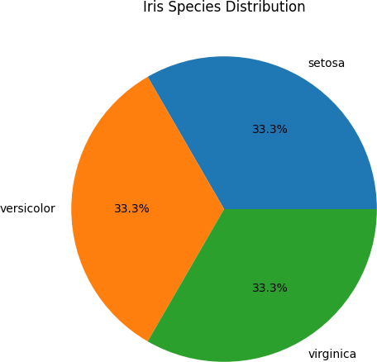

Start coding or ge nerate with AI.